Subject: Competent Authority Approval for Restricting PDF Bid Documents from
Being Shared with Other Bidders.
Approval is hereby granted to the decision not to share or display any bidder's PDF documents with other participating bidders.
This measure has been approved to ensure:
1. Confidentiality of bid submissions,
2.Faimess and transparency in the procurement process, and
3.Compliance with relevant procurement guidelines.

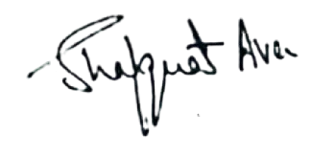

Principal,
Kashmir Government Polytechnic
Srinagar.
No: KGP/Estt/2025/1852
Dated: 23-12-2025

Copy to the:
- GeM Buyer for the information and necessary information.
- Accounts Section for information.

